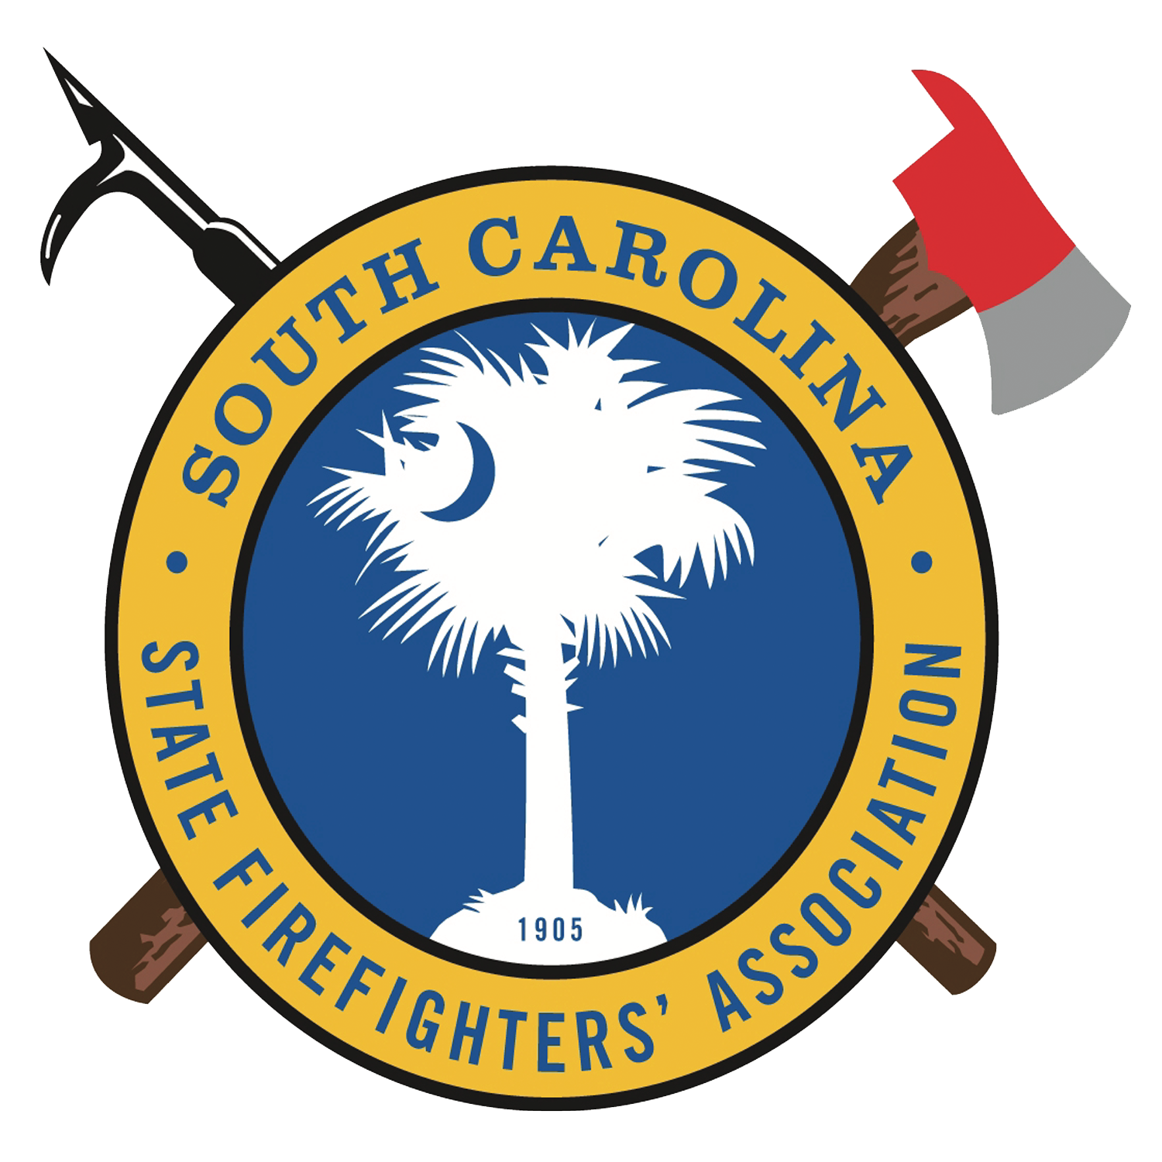
Fire-Rescue
BBQ Registration Form

Name:

Address:
Email Address:

Cell:
Fire Department Affiliation (required):
Active Retired Career Volunteer

Team Name:
Head Cook Name:
Assistant 1
Assistant 2
Assistant 3

A $50.00 check deposit is required with your registration. Please send all registrations by May 18, 2018 to:

SCSFA – BBQ Competition
Attn: Ashley Boltin
PO BOX 211725
Columbia, SC 29210

